## 5.1 Three Design Ideas

|  |
| --- |
| **Instructions**  You should produce a sketch that shows the appearance of the screen or screens. The number of screens you mock-up will be determined by your Evaluation Criteria.  At a minimum, you mock-up should show:   * Position and relative size of controls * Position, size, colours and style of text (headers and body text) * Menu positions, styles and content * Input boxes and their default prompts * Borders, frames, shapes, images, decorations and colour schemes * Object alignment * Content of headers and footers |

5.1.1 Design 1 Mock-Ups

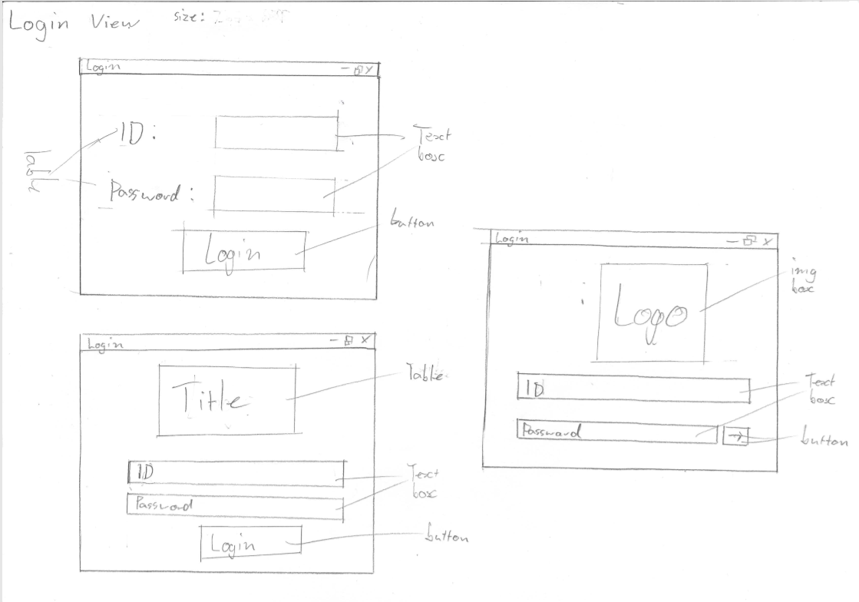

### 5.1.2 Design 2 Mock-Ups

### 

### 5.1.3 Design 3 Mock-ups

### 

### 5.1.4 Data Dictionary

|  |  |  |  |  |  |  |  |
| --- | --- | --- | --- | --- | --- | --- | --- |
| **Name** | **Data Type** | **Format** | **Length** | **Required?** | **Validation** | **Description** | **Sample** |
| Last Name | String | - | 10 | no | No | Account user last name | Smith |
| First Name | String | - | 10 | no | No | Account user first name | Zachary |
| ID | String | AAA0000  (3 alphabetic letters followed by 4 numeric digits) | 7 | yes | Yes | Represents a user | SMI0009 |
| Time | time | 00:00 | - | yes | Yes | 24 hour time | 09:36 |
| Hours | Numeric | - | 2 | yes | yes | Hours done | 8 |

### 5.1.5 Pseudocode

Button from form to form

START

DIM next form as new form

Next form show

Next form = nothing

Hide previous form

END

Load list view (admin form)

START

filename as string = “file.txt”

set filenum

set list view as list view

set columns in list view

open file

DO UNTIL

Read lines

Enter data into text file

LOOP

Display

Close file

END

Button Add (Admin from)

START

filename as string = “file.txt”

set filenum

set list view as list view

set columns in list view

open file

DO UNTIL

Read lines

Enter data into text file

LOOP

Display

Print line

Close file

END

Button remove (Admin form)

START

filename as string = “file.txt”

set filenum

set list view as list view

set columns in list view

open file

DO UNTIL

Read lines

Enter data into text file

LOOP

Display

Remove line

Close file

END

Button to login (Login form)

BEGIN

READ password

IF password AND username IS Admin and admin0123 THEN

DIM next form as Admin

Display next form

Next form = nothing

Hide Login form

ELSE

IF attempts < 3 THEN

Password text = “”

Show message box “Incorrect”

ELSE

IF password AND username IS Staff and staff0123 THEN

DIM next form as Staff

Display next form

Next form = nothing

Hide Login form

END IF

END IF

END IF

END

Search function (Admin form)

BEGIN  
 size <- 99  
 READ registration  
 index <- 0  
 found <- false  
 REPEAT  
 index += 1  
 found <- registration = reg(index)  
 UNTIL found= true OR index = size  
 IF found THEN  
 DISPLAY reg(index), make(index), model(index), year(index), odometer(index), cost(index) ELSE  
 DISPLAY 'registration not found'  
 END IF  
END

### 5.1.6 Object Descriptions

|  |  |  |  |
| --- | --- | --- | --- |
| **Object Name** | **Properties** | **Methods** | **Events** |
| Text box | - | User types in box | Read txt box |
| Drop down box | - | User selects day within drop down box | Form reads and records day |
| Button | - | This can to many things like; next form or go back, record time in and remove/add member | - |
| List View | - | - | Read calculate and display staff information |

## 5.2 Evaluation of three designs

|  |
| --- |
| **Instructions**  Example Evaluation Criteria  Design Evaluation Rubric Template |

### 5.2.1 Evaluation Criteria

My client had a few requests when it came to functional and non-functional requirements. Functional being that the program could do its intended purpose of displaying staff data and staff hours per week. And the non-functional requirements being that it is user friendly for all staff and part-time staff to use and could be maintained easily by the admin.

### 5.2.2 Evaluation of each design

**Login Screen:**

The login screen drafts all try to achieve the non-functional requirement of it being easily read and understood by the user/staff member. There is little clutter on the screen of the from on all drafts to make it easy to read and understand, the main difference being the location or presence of the login button. The first two designs have large buttons in the centre of the bottom of the screen so it is obvious for the user to navigate to it when ready. But on the third draft of the login form the button is smaller and more attractive as is a smaller button fitted in next to the password with no words on it but only an arrow (🡪). All three designs vary in the top of the screen as each displays the Child care logo or text differently. The first draft displays no label or logo as staff know where they are, the second draft has an area allocated for a label to display the child care title or instruction and the third design has an area for the logo with no instructions and just for aesthetic looks.

**Admin Screen:**

The admin screen is one of the important screens as this were the functional requirements are displayed. In the first design all buttons are placed towards the bottom to make the looks more flush with the area give in the form. But in the second design a text box is introduced to the form to make the list view function easier to function and understand, but the button are skewed and spread out around the screen making it harder on the user as all parts of the screen have to be looked at to complete all functions. This is fixed in the third draft as the button locations are organised so they are closer together. The horizontal length of the list view is extended so all buttons and the text box is easily fitted along the top of the list view making the form easier on the eyes.

**Staff Screen:**

The staff screen is meant to be as simple and straight on as this is the screen all staff will see, is simple and straight on giving staff little choice in what to do. There is text box as it is not necessary and no efficient for this function. Two buttons are used for staff to say if they are logging in or out. In the two drafts there are different methods of choosing the day of the week, Radio buttons are used to select the day or a dropdown box is used. A label can also be implemented into both designs to display instructions.

## 5.3 Client Feedback

The client had one preference for all designs. This was the ones that are user friendly and easy for staff to understand and navigate. The only exception being the admin view as the admin should know what they are doing so the design did not have to be too simplistic but has to have more accuracy

## 5.4 Justification for the chosen design

|  |
| --- |
| **Instructions**  With reference to the evaluation process, explain why you have selected your chosen design. |

Completeness:

The main aim of the design is to be as effective as possible as well as achieve the functional and non-functional requirements of each screen. The final design of the login screen and staff screen achieves this as it looks simple and has large buttons so staff can quickly navigate to it.

Readability:

The readability of the Staff and Login screen is easy to read and understand as words are in a simple font with a light background and dark letters making the contrast easy to look at. The Admin screen are not as easy to read as the words are smaller so all the functions and information can fit in.

Functionality:

The designs overall function well and can respond well to user inputs. The Staff screen has reduced options so the users cannot do errors as often due to the restricted options available. Most errors will occur in the text box of the admin screen, but because the admin should have some sort of experience in the program this should not happen often.

Relevance:

All information inputted to the program is necessary for the outcome and functional requirements. In the staff screen the day and time of the staff member is inputted and stored to be used latter for calculations of hours done.

Accuracy:

All data stored is done accurately in the relation of how it was inputted. Because of how data is stored all calculations should be 100% accurately.

Usability:

Overall, the program for all staff members should be easy to use, for staff the biggest area of error will be in the login screen if they input there ID and password wrong. Errors will most likely occur in the admin screen but because the admit will be experienced in navigating the software it will not happen often meaning this program will be overall easy to use

